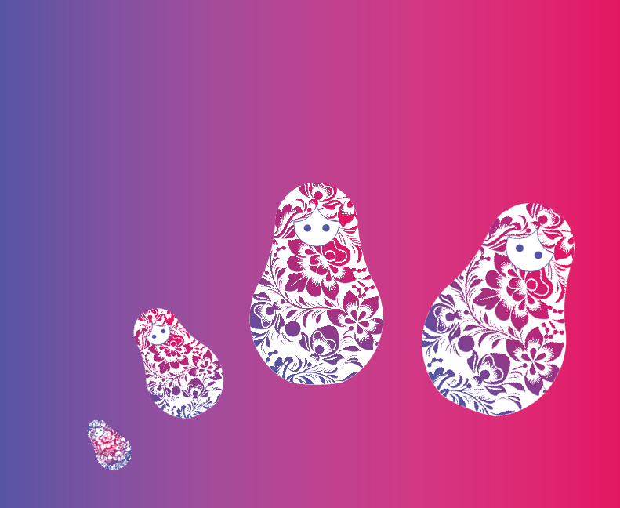**08.11.2018 - 09.11.2018, Moscow (1 night), 15-25 PAX**

**2 days / 1 night**

**Test**

**Based on 15 - 25 PAX**

**8 - 9 November 2018**

**Day 1) Moscow, 8 November 2018 (Thursday)**

* MEETING WITH ENGLISH-SPEAKING GUIDE

**BUNKER-42 (ZKP, 85 MIN.)**

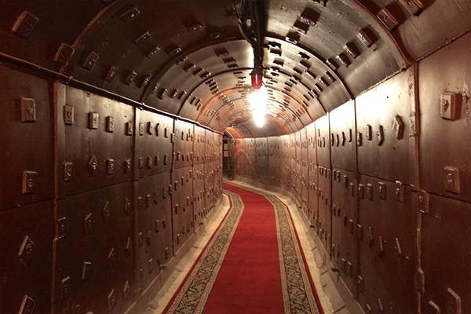A real bunker, which was built in the 50s by the order of Stalin as a nuclear shelter for the first persons of the USSR. It was designed after the first series of nuclear tests of the Soviet Union. The bunker occupies more than 7000 square meters and is located 65 meters below the ground level. During the excursion you will hear interesting facts about the Cold war, how close was the threat of Nuclear World War, and you will learn about the facilities which were protected people from all factors of atomic explosion.

* ARRIVAL AT THE AIRPORT
* CHECK-IN AT THE HOTEL
* LUNCH AT THE HOTEL
* DINNER AT THE HOTEL
* OVERNIGHT IN THE HOTEL

**Day 2) Moscow, 9 November 2018 (Friday)**

* BREAKFAST AT THE HOTEL
* CHECK-OUT OF THE HOTEL
* LUNCH AT THE HOTEL
* DINNER AT THE HOTEL
* DEPARTURE FROM THE AIRPORT

The order of the visits might be changed. However, all visits mentioned in the program will be provided in full.

**NET PRICE PER PERSON PER PACKAGE, IN ½ DBL, IN EUR\***

2 days / 1 night - for 15 to 25 PAX - 8 to 9 November 2018

**Based on Hotel 4* "Park Inn Sadu", "Mandarin" in Moscow or similar**

|  |  |  |  |  |
| --- | --- | --- | --- | --- |
| **Dates** | **15 PAX** | **20 PAX** | **25 PAX** | **SGL SUP.** |
| **8 - 9 November 2018** | 196€ | 198€ | 197€ | 48€ |

* All rates are subject to change in case of EUR/RUR exchange rates fluctuations more than 5% compared to the official Russian Central Bank rate established on 08.11.2018 unless deposit or full payment is already done.

|  |  |  |
| --- | --- | --- |
| **Price includes** | | **Price does not include** |
| * 1 night in chosen hotel in Moscow * Transport services as per the program * English-speaking guide services as per the program * Meals as per program * Entrance fee as per the program * Visa support letter (scan) if required | * Tips * Photo and video shooting tickets * Meals and beverages except mentioned * Russian visa fees * DHL service * Flights * Options | |